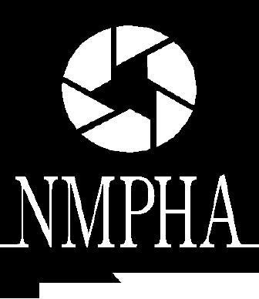

NEW MEXICO PUBLIC HEALTH ASSOCIATION
“Working Towards una Cultura de Salud:
Policies that Drive Action”

15th Annual Health Policy Legislative Forum

Friday, December 7, 2018

Hilton Santa Fe Historic Plaza Hotel
100 Sandoval Street, Santa Fe

Please complete the form below and return by email to Shelley Mann-Lev at shelleymannlev1@gmail.com with “NMPHA Health Policy Legislative Forum Scholarship” in subject line. Requests will be accepted by email until Friday, November 17th. Applicants will be notified of approval via email no later than Wednesday, November 22nd. Please note that the number of scholarships given is dependent on the sufficiency of sponsorships for the Health Policy Legislative Forum.

For more information or questions, contact:
Shelely Mann-Lev at: shelleymannlev1@gmail.com or
Deborah Kendall-Gallagher at debkg18@gmail.com

- Name:

- Are you requesting a scholarship to attend as:

- A student
  - School:

- A representative of an organization
  - Organization and position:

- An interested community member

- Other:

- Email:

- Brief statement about why scholarship is needed (4-5 sentences):

